x) Read and summarize (briefly, e.g. with some bullets)

* Quintin 2014: [7 Things You Should Know About Tor](https://www.eff.org/deeplinks/2014/07/7-things-you-should-know-about-tor)
  1. Tor still works, attacks happen due to user misconfiguration, correlation attacks
  2. Tor is not only used by criminals but can rather be used to protect against criminals online and for secure communication.
  3. Even though Tor was funded by the US navy, it does not have a back door and nothing suspicious is in the source code.
  4. No one in the US has ever been prosecuted for running a Tor relay. IT is believed to be legal.
  5. Ease to use, just download the browser bundle or use Tails which is a live OS it runs on DVD, and other external drives.
  6. Tor is not slow and connections can be sped up using by creating relays.
  7. Do not use personal accounts on services as it defeats the privacy purpose.
* Shavers & Bair 2016: [Hiding Behind the Keyboard: The Tor Browser €](https://learning.oreilly.com/library/view/hiding-behind-the/9780128033524/XHTML/B9780128033401000021/B9780128033401000021.xhtml#s0010); subchapters: "Introduction", "History and Intended Use of The Onion Router", "How The Onion Router Works", "Tracking Criminals Using TOR".
* Intro

- Tor browser: based on Firefox, enables anonymous Internet use.

- Hides IP address when browsing or emailing.

- Extremely hard to track or identify users.

- User-friendly and easy to use without technical knowledge.

- One of the simplest and freely downloadable tools for anonymous web browsing

* How the onion router works

- Routes internet traffic through random relays.

- Data encrypted with secure elliptic curve cryptography.

- Encryption layers peeled off at each relay: entry, middle, exit.

- Entry relay receives encrypted data, removes a layer.

- Middle relay repeats the process.

- Exit relay connects to the user's target without encryption.

* + 1. Install TOR browser and access TOR network (.onion addresses). (Explain in detail how you installed it, and how you got access to TOR).

I downloaded the installation file from torproject.org and then used the command line to extract it.

I then opened the directory where the executable file was saved and run the browser from there.

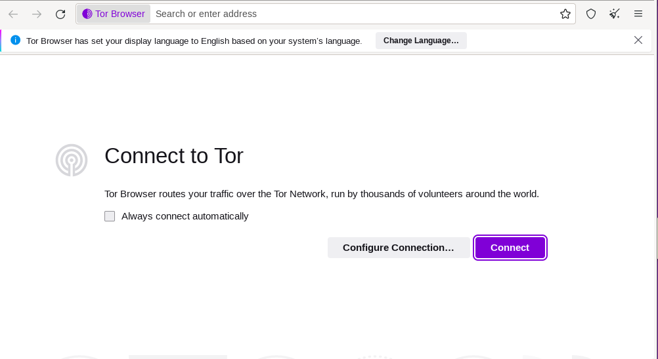

I do not have any specific configuration ideas, so I left it on default and just connected to the browser.

.Onion addresses can be opened with the tor browser only, they allow encryption and hide ip-addresses. These sites are unindexed, but you can find such addresses by performing a search on the search engine and find .onion links. Some of these sites are dangerous and should be accessed with the safest settings enabled.

* + 1. Browse TOR network, find, take screenshots and comment

Some popular search engines: Duckduckgo, Torch, Recon, Ahmia

I am using Ahmia to browse around the marketplace:

* A site for a well known organization that has a physical street address in the real world

